UNIT-2

10-Step M&A Process
If you work in either investment banking or corporate development, you’ll need to develop an M&A deal process to follow. Investment bankers advise their clients (the CEO, CFO, and corporate development professionals) on the various M&A steps in this process.
A typical 10-step M&A deal process includes:
- Develop an acquisition strategy – Developing a good acquisition strategy revolves around the acquirer having a clear idea of what they expect to gain from making the acquisition – what their business purpose is for acquiring the target company (e.g., expand product lines or gain access to new markets)
- Set the M&A search criteria – Determining the key criteria for identifying potential target companies (e.g., profit margins, geographic location, or customer base)
- Search for potential acquisition targets – The acquirer uses their identified search criteria to look for and then evaluate potential target companies
- Begin acquisition planning – The acquirer makes contact with one or more companies that meet its search criteria and appear to offer good value; the purpose of initial conversations is to get more information and to see how amenable to a merger or acquisition the target company is
- Perform valuation analysis – Assuming initial contact and conversations go well, the acquirer asks the target company to provide substantial information (current financials, etc.) that will enable the acquirer to further evaluate the target, both as a business on its own and as a suitable acquisition target
- Negotiations – After producing several valuation models of the target company, the acquirer should have sufficient information to enable it to construct a reasonable offer; Once the initial offer has been presented, the two companies can negotiate terms in more detail
- M&A due diligence – Due diligence is an exhaustive process that begins when the offer has been accepted; due diligence aims to confirm or correct the acquirer’s assessment of the value of the target company by conducting a detailed examination and analysis of every aspect of the target company’s operations – its financial metrics, assets and liabilities, customers, human resources, etc.
- Purchase and sale contract – Assuming due diligence is completed with no major problems or concerns arising, the next step forward is executing a final contract for sale; the parties make a final decision on the type of purchase agreement, whether it is to be an asset purchase or share purchase
- Financing strategy for the acquisition – The acquirer will, of course, have explored financing options for the deal earlier, but the details of financing typically come together after the purchase and sale agreement has been signed
- Closing and integration of the acquisition – The acquisition deal closes, and management teams of the target and acquirer work together on the process of merging the two firms

Structuring an M&A Deal
One of the most complicated steps in the M&A process is properly structuring the deal. There are many factors to be considered, such as antitrust laws, securities regulations, corporate law, rival bidders, tax implications, accounting issues, market conditions, forms of financing, and specific negotiation points in the M&A deal itself. Important documents when structuring deals are the Term Sheet (used for raising money) and a Letter of Intent (LOI) which lays out the basic terms of the proposed deal.
To learn more, watch CFI’s free Corporate Finance 101 course.

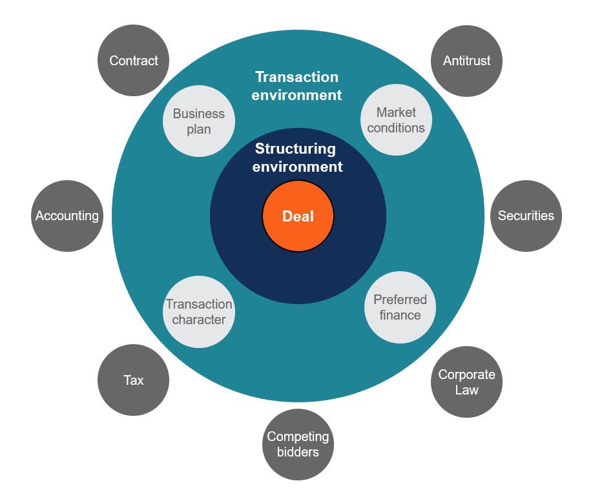

Rival bidders in M&A
The vast majority of acquisitions are competitive or potentially competitive. Companies normally have to pay a “premium” to acquire the target company, and this means having to offer more than rival bidders. To justify paying more than rival bidders, the acquiring company needs to be able to do more with the acquisition than the other bidders in the M&A process can (i.e., generate more synergies or have a greater strategic rationale for the transaction).

Strategic vs Financial Buyers in M&A
In M&A deals, there are typically two types of acquirers: strategic and financial. Strategic acquirers are other companies, often direct competitors or companies operating in adjacent industries, such that the target company would fit in nicely with the acquirer’s core business. Financial buyers are institutional buyers, such as private equity firms, that are looking to own, but not directly operate the acquisition target. Financial buyers will often use leverage to finance the acquisition, performing a leveraged buyout (LBO).
We discuss this in more detail in the M&A section of our Corporate Finance course.

Analyzing Mergers and Acquisitions
One of the biggest steps in the M&A process is analyzing and valuing acquisition targets. This usually involves two steps: valuing the target on a standalone basis and valuing the potential synergies of the deal. To learn more about valuing the M&A target see our free guide on DCF models.
When it comes to valuing synergies, there are two types of synergies to consider: hard and soft. Hard synergies are direct cost savings to be realized after completing the merger and acquisition process. Hard synergies, also called operating or operational synergies, are benefits that are virtually sure to arise from the merger or acquisition – such as payroll savings that will come from eliminating redundant personnel between the acquirer and target companies.
Soft synergies, also called financial synergies, are revenue increases that the acquirer hopes to realize after the deal closes. They are “soft” because realizing these benefits is not as assured as the “hard” synergy cost savings. Learn more about the different types of synergies.

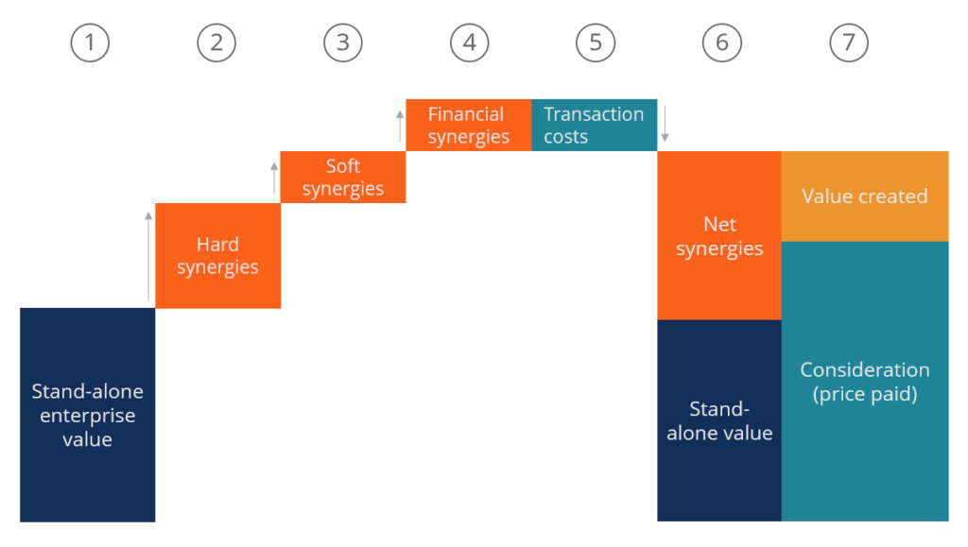

1. Introduction Takeovers are important events. In 1999, global mergers and acquisitions accounted for 2 percent of world-wide GDP (UNCTAD 2000). The financial performance of corporate takeovers is one of the most researched areas in industrial economics and financial economics. Despite this, the question of whether takeovers improve corporate performance is controversial. Accounting studies examine whether accounting performance improves after acquisition. This evidence is mixed with a small number of studies showing improvements in profitability, but the majority showing no improvement.1 Event studies examine the stock market’s short-term reaction to the takeover announcement. These event studies show significant gains for target shareholders, and no gains or losses for acquiring shareholders, but significant gains overall. The much smaller number of event studies, which examine the long run share returns following acquisition find evidence of significantly negative losses. The interpretation of these stylised facts varies considerably. Some authors claim that the methodology used to measure long run share returns is not reliable and that takeovers create value both in terms of profits and short run share price gains (Andrade, Mitchell and Stafford 2001). In contrast, others argue that the long run negative share returns reflect overvaluation of takeovers at the time of announcement, which ultimately do not improve profits and destroy shareholder value (Tichy 2002). From the perspective of financial theory, a key question is whether the present value of the financial benefits from acquisition are greater than the present value of the costs, including the initial investment. What is at issue here is whether the marginal return from acquisition is greater than the marginal cost. However, neither the event study nor accounting study approaches are designed to address this key issue. The stock market reaction to a takeover bid reflects many factors, and not just the marginal impact of acquisition. The accounting studies on the other hand do not explicitly account for the cost of the acquisition, the time value of money, or profits earned beyond a limited post-acquisition period. During the last decade, accounting research has re-explored fundamental approaches to corporate valuation. In this spirit, models based on residual income have been developed (see e.g. Feltham and Ohlson 1995), and attained a widespread use in practical valuation settings (Penman 2000). In this paper we use the residual income approach to develop a metric for empirical evaluation of the financial performance of takeovers that is consistent with fundamental valuation theory and that hence overcomes some of the deficiencies of the event and accounting performance studies. In particular, we estimate the fundamental valuation of the bidder before the acquisition and compare this valuation with the fundamental valuation following the acquisition. If takeovers create fundamental value, then the latter should be greater than the former. We apply this methodology to a comprehensive sample of domestic U.K. acquisitions involving public companies, completed between 1985 and 1996, and compare the results with those using the traditional accounting measure. We find that, when using the traditional accounting method, acquisitions result in a significant improvement in return on equity. However, when using the residual income approach, acquisitions result in a significantly lower fundamental value of the acquiring company than existed prior to acquisition. Our conclusion is that acquisitions actually destroy fundamental value. The paper is organised as follows: Section 2 discusses why the traditional approaches fail to measure the marginal impact of acquisition. Section 3 reviews the residual income approach to valuation, and develops a model based on this approach to measure takeover performance. Section 4 describes the data and sample statistics. Section 5 reports the results from the empirical analysis. Section 6 concludes. 2. Why Event and Accounting Studies do not Measure the Impact of Takeover on Fundamental Valuation 2.1 Event studies There are several reasons why stock market reaction at the time of the announcement of an acquisition may not reflect whether the acquisition has a positive impact on fundamental valuation or not. An acquisition announcement provides a bundle of signals all of which generate information, that is reflected in the security price of the acquiring company. These signals give information on the event itself, the identity of the acquirer, and the method of payment, among others. For example, studies have shown that acquirers using stock as the method of payment experience lower returns than those using cash. One explanation for this empirical finding is that acquirers offer stock when they are overvalued by the stock market (Myers and Majluf 1984). Alternatively, when a firm takes on any new project with a positive net present value, the market value of the firm will be affected, depending on whether the NPV meets expectations. If a firm is expected to take on high positive NPV projects, then this expectation will be built into value. Even if the new projects taken on by the firm have a positive NPV, there may be a drop in value if the NPV does not meet the high expectations of the stock market. To disentangle the impact on stock prices of these signals and thereby evaluate whether the marginal benefit of the acquisition is greater than the cost is very difficult. 2.2 Accounting studies There are several reasons why the accounting studies do not measure the impact of an acquisition on fundamental value. The methodology typically used addresses the question of whether the postmerger performance of the merging firms differs from the pre-merger performance. Such accounting indicators are not clearly related to whether the acquisition is a net NPV positive investment for the acquirer or not. Firstly, the appropriate consideration is the marginal return brought by the acquisition compared to the acquirer’s cost of capital. The pre-merger performance of the acquired company is of no relevance here. Some studies have alternatively considered the difference between the post-bid performance of the acquirer with the pre-bid performance of the acquirer only (Dickerson, Gibson, and Tsakalotos 1997): Healy, Palepu and Ruback 1997). However, whether acquirer performance improves or deteriorates does not tell us whether fundamental value is created. This requires estimation of whether the additional profit returns brought about by the acquisition are greater than the cost of capital. In other words the profitability of the acquirer could be lower following acquisition, but the marginal profitability may be higher than the cost of capital, or vice versa. It is therefore important to compare the marginal profitability associated with the acquisition to the acquirers cost of capital. Furthermore, studies tend to give equal weight to each post-takeover year. However, if the timing of profits is of crucial importance in establishing whether acquisitions improve fundamental valuation. It is therefore important to weight future profits by the cost of capital to represent the higher value accorded to profits which occur sooner rather than later. Since acquisitions have important effects on capital structure and hence the cost of capital (Ghosh and Jain 2000), it is the post-acquisition cost of capital which is relevant here. Furthermore, in both the above types of studies, the profitability measure is adjusted for factors such as industry and size. Takeovers are classified as successful if they outperform the expected performance of similar size and/or industry counterfactuals. However, this adjustment says nothing about whether the relative performance is sufficient in absolute terms. A return that is worse than that of the control firms can still be satisfactory compared to the cost of capital and vice versa. Another serious drawback of the existent literature is the treatment of goodwill. Since their objective is to compare the post-acquisition performance of the merged firms with the pre-acquisition of the merged firms, the inclusion of purchased goodwill on the merged firms books following the acquisition produces a downward bias on profitability change.2 Studies have typically therefore subtracted goodwill from the merged firms’ assets and added back amortisation to the profitability measure.3 The studies have effectively converted the profitability effect into that that would occur with the pooling method.4 As a result, the cost of the acquisition is not incorporated into the performance measure. Acquiring firms can pay a higher premium and therefore reduce the fundamental valuation of the acquisition, but this will not be reflected in the accounting performance measurement. Most profit studies ignore the profitability beyond an initial (usually 3-5 years) post-acquisition period.5 However, the returns beyond this period are crucial to understanding the fundamental valuation of the acquisition. Our methodology attempts to overcome the above shortcomings by taking into account only the performance of the acquiring company, by comparing profit returns with the cost of capital, by taking into account performance beyond the initial post-acquisition period and by explicitly allowing for the cost of goodwill.

FUNDING
ecuring funding for a merger and acquisition (M&A) can be a complex process. Here are some acquisition financing strategies to increase your chances of success:

- Identify your funding needs - Before approaching potential investors or lenders, you need to determine how much funding you require. This will depend on the size and complexity of the M&A deal, as well as the amount of capital you already have available.
- Develop a clear M&A strategy - You need to have a clear understanding of the target company or assets you want to acquire, the potential benefits of the acquisition, and the risks involved. You should also have a plan for how you will integrate the acquired business or assets into your existing operations.
- Identify potential funding sources - There are several options for funding an M&A transaction, including equity financing, debt financing, and alternative financing sources like venture capital or private equity. Each option has its own advantages and disadvantages, so it's important to evaluate each option carefully and choose the one that best fits your needs.
- Prepare a comprehensive business plan - Your business plan should outline the details of the M&A transaction, including the expected costs, projected revenue, and potential risks. You should also provide financial statements, market research, and other supporting documentation to help investors or lenders make well-informed decisions.
- Seek professional advice - It's important to seek the advice of experienced professionals, such as investment bankers, attorneys, and accountants, to help you navigate the complex M&A process and ensure that you are following all legal and regulatory requirements. They can also help you negotiate favourable terms with potential investors or lenders.

Types of acquisition funding available
There are several types of acquisition funding sources available, including:

- Equity Financing for acquisition - This involves selling a stake in your company to investors in exchange for funding. It can be a good option if you have strong growth potential or if you want to retain control of your company.
- Debt Financing for acquisition - This involves borrowing money from a lender, such as a bank or private equity firm, and paying it back with interest over time. It can be a good option if you have a solid business plan and a stable cash flow to support your debt payments.
- Mezzanine Financing - This is a hybrid form of financing that combines elements of debt and equity. It involves borrowing money from a lender, but with the lender also taking an equity stake in your company. It can be a good option if you need more capital than you can get through traditional debt financing.
- Venture Capital funding - This involves raising money from investors who are looking for high-growth companies with the potential for significant returns. Venture capitalists typically take an equity stake in your company and may also provide guidance and mentorship for running the show.
- Private Equity funding - This involves raising money from investors who are looking for established companies with strong cash flows and the potential for growth. Private equity investors typically take a controlling stake in your company and work closely with management to increase its value.
- Crowdfunding - This involves raising small amounts of money from a large number of individuals through online platforms. It can be a good option if you have a strong online presence and a compelling story to tell.

According to the Australian Government’s business.gov.au website, fluctuations in cash flow can have a serious effect on a business’s viability. As a result, one of the most common reasons a business seeks financial assistance is due to cash flow. But there are many other reasons why a business owner might seek funding. You might need business financing:
- to help establish a new business
- to purchase or lease property such as a factory or store
- to expand a business or begin engaging in international trade
- to purchase stock
- for investment in vehicles, machinery or other tools and equipment
- for research and development
- during times of difficulty to help the business survive

New challenges in business finance
The global pandemic and its aftermath wreaked havoc on the world’s businesses, but when we finally emerged from COVID, business leaders and owners faced new challenges.
The smallest SMEs to the largest multinational companies felt the impact of global supply chain issues, increased costs, skilled worker shortages and ongoing global uncertainty. Record levels of inflation and rising interest rates put pressure on households, consumers and business owners alike.
According to a recent KMPG report, business leaders have also been left with concerns about staff acquisition and retention, cybersecurity and digital transformation, the disruption of remote workplaces as well as new technologies. If businesses are to survive in the future, they simply have to innovate.
There is no doubt that the way we do business has changed, and that includes finding new ways to access business finance. The good news is there are a variety of methods available to finance your business. Options range from the traditional, like loans and overdrafts, to the more flexible, like Debtor Finance and Trade Finance.
You’re probably familiar with the traditional funding options, but the more innovative types may actually suit your business better.
Let’s examine the various finance options available.

Traditional methods of financing a business
The Reserve Bank of Australia reports that since the second half of 2021, small and medium businesses have experienced relatively strong growth conditions. As a result, demand is high for business finance. But though demand is strong, businesses face many hurdles, including rising interest rates. This makes accessing traditional bank funding difficult.
So, how do you finance a business? Many business owners still default to familiar, conventional options when they need financing, and there are three basic ways to go about it. It can be achieved by:
- using internal funds
- organising debt finance
- arranging equity finance
Each of these options has benefits and drawbacks. Let’s take a look at each.

Business Financing Method #1 — Internal Funds
As a business owner, you might prefer to fund your expenses and growth through internal funds, such as the cash and savings you already have sitting in your business. These internal funds might come from profits you’ve already enjoyed or by selling assets the business no longer needs. The main advantage of using internal business funds is that you don’t have to take on debt or repay any money to a third party.
However, internal funding or internal financing uses up your company’s available cash or assets, which may cause cash-flow problems later on when it’s time to pay expenses. It may also stifle your business’s growth by keeping you from taking advantage of opportunities that require readily available funds.

Business Financing Method #2 — Debt Finance
Financing your business through debt involves borrowing money from a lender, such as a bank or other financial institution. It most often takes the form of credit cards, overdrafts, lines of credit or loans.
On the plus side, this generally allows you to keep control of your business and profits, because no other parties have any ongoing shared ownership over your business. Plus, the interest paid is often tax-deductible.
The main disadvantage, of course, is that you need to repay the money you borrow — usually with interest. And in the days of rising interest rates, that’s of real concern. The RBA has recently indicated that not only will rates not fall in the near future, they will probably continue to rise.
So, while debt finance can be a good short/mid-term fix, it can also lead to more problems in the future. Many businesses also find it challenging to get debt finance without offering personal asset security, particularly if they’re just starting out or don’t have sufficient equity. But for an established business that is looking for funding to grow, debt finance is often a solid option.

Business Financing Method #3 — Equity Finance
The third popular business capital solution is equity finance, where an investor provides funding in exchange for owning a piece of your business. Typical examples of investors include venture capitalists (professionals who invest in existing companies) and angel investors (individuals who invest in start-ups).
This can be less risky than debt financing, as the investment isn’t a debt you need to repay.
The downside is that you lose control and ownership of part of your business. It can also be hard to find the right investors — people who are both willing to invest and who you want to share future ownership with.

Sources of Finance
A company can raise capital from a variety of sources. Each source has distinct features that must be properly analyzed in order to choose the greatest accessible method of obtaining finances. For all organisations, there is no one optimum source of funding. A choice of the source to be used may be made depending on the situation, purpose, cost, and associated risk.
Finance is required at the point when an entrepreneur decides to launch a business. For example, funds are needed to buy furniture, equipment, and other fixed assets. Similar to this, funds are needed for regular operations, such as buying supplies or paying employees’ salaries. Additionally, a business needs funds to expand. For Example, if a company wants to raise funds to fulfil its fixed capital requirements, long-term finances may be necessary, which can be raised through either owned or borrowed funds. Similarly, if the goal is to meet the day-to-day needs of the business, short-term sources may be utilized.
Without sufficient funding, a business is unable to operate. The entrepreneur’s initial investment may not always be enough to take care of the company’s entire financial needs. As a result, a businessman needs to look for various other sources where the need for funds can be satisfied. Running a business organisation, therefore, requires a clear understanding of the financial requirements and the identification of various sources of funding.

Different Sources of Finance

